Mindfulness activities – you don’t just have to use them this week, use them whenever you need a brain break!
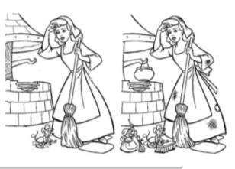
Create your own spot the difference. Split your page into two. Draw a picture in the left-hand box and colour it in. Draw the same picture in the right-hand box but make 5 very subtle changes. Give it to someone to complete or send it to school and we’ll have a go!

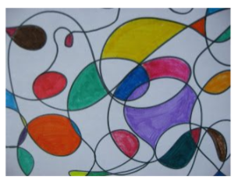
Using a plain piece of paper, start with your pencil in the bottom left-hand corner and draw one long, continuous line. Do circles and loops but do not take your pencil off the page! Finish at the top right-hand corner. You will be left with lots of strange shapes. Colour these in until you have a page full of colourful shapes!

