Flying to Nairobi

Today we are going to board a flight to Kenya! This requires lots of imagination!

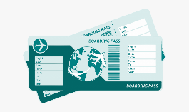
Talking Time: Have a think about what you might pack to take with you. Will it be hot or cold there? Will you need sun cream or a scarf? What shoes will you need?

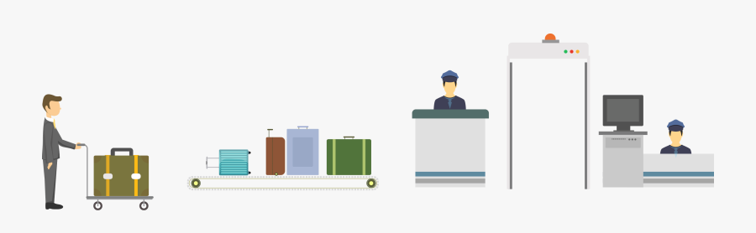
- Let’s check in! https://www.youtube.com/watch?v=gdjrHR4w-fY You could make your own boarding card!
- Airport security https://www.youtube.com/watch?v=rwkBvz_i870

Thinking Time: How did it feeling going through security? Why do you think we do this?
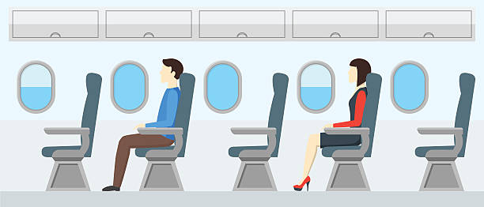
- Departure lounge https://www.youtube.com/watch?v=7ahopPkenhM
- Boarding and Taking off https://www.youtube.com/watch?v=SnAYtU3nc0g

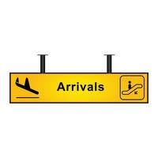
Talking Time: What will it be like when we land? Will the airport look the same? What should I do on the plane?

- Landing https://www.youtube.com/watch?v=lJe1DWHf-lQ
- Jomo Kenyatta airport arrivals https://www.youtube.com/watch?v=jp129KYig7M

Talking Time: We made it to Nairobi! How exciting! What was your favourite part of the journey?
Tomorrow we will explore more of Nairobi!

