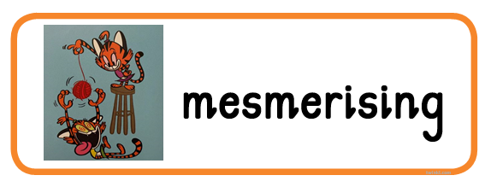
mesmerising (adjective) very attractive or bewitching; like something that hypnotises and distracts you
Word pairs: effect, music, spell

