Spelling List Crossword
Initial Sound Followed by Double Consonant
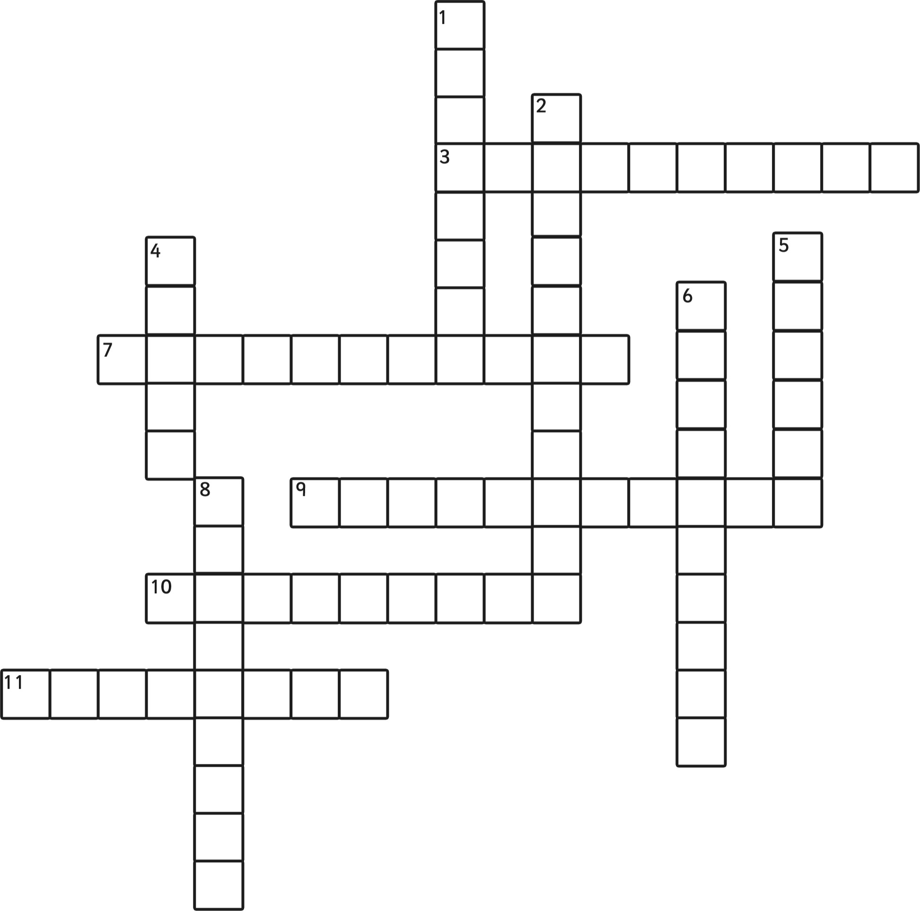
HINT
Question 7 across: accommodate
An initial sound (a) followed by a double consonant (cc) is “accommodate”. The initial sound is given and the spelling is completed by adding the correct double consonant and completing the word.

Across
3. l a any help I get.
7. The house can a 5 people.
9. I called i for help.
10. Will you a me to the shops?
1 1. For no a reason he smiled.

Down
1. She a it with string.
2. I wish I had the o to visit another country.
4. What time did it o
5. I o_____ my free time by reading.
6. The cat was a______ towards the dog.
8. Bake the cake a________ to the instructions in the book.

